Software Requirements Specification  
Version 1.0  
<<Annotated Version>>  
May 15, 2021  
Programing Quzi System  
AbdAlrhman Aljidy Team leader  
AbdAlKareem Soufan  
Submitted in partial fulfillment  
Of the requirements of  
CS 310 Software Engineering

**Table of Contents**Table of Contents...............................................................................................................................   
List of Figures.......................................................................................................................................   
1.0. Introduction...................................................................................................................................   
1.1. Purpose ................................................................................................................................................   
1.2. Scope of Project...................................................................................................................................   
1.3. Glossary...............................................................................................................................................   
1.4. References ...........................................................................................................................................   
1.5. Overview of Document .......................................................................................................................   
2.0. Overall Description............................................................................................................   
2.1 System Environment.......................................................................................................................   
2.2 Functional Requirements Specification ..........................................................................................   
2.2.1 User Use Case.....................................................................................................................   
Use case: start the quiz ....................................................................................................................   
2.2.2 Prof Use Case.....................................................................................................................   
Use case: takes pattrens ....................................................................................................................   
2.2.3 User Use Case.................................................................................................................   
Use case: ask for certificate ..................................................................................................................   
   
3.0. Requirements Specification .........................................................................................   
3.1 External Interface Requirements ...................................................................................................   
3.2 Functional Requirements ..............................................................................................................   
3.2.1 start the quiz ........................................................................................................................   
3.2.2 takes pattrens.........................................................................................................................   
3.2.3 ask for certificate...................................................................................................................  
 3.3 Detailed Non-Functional Requirements ........................................................................................   
3.3.1 The speed performance of server.................................................................................................   
3.3.2 security of the quiz..........................................  
3.3.3Reliability……………………..........................................  
3.3.4The quality of question……………………..........................................

**1.0. Introduction  
*1.1. Purpose:***

The purpose of this document is to present a detailed description of the Automated Programming knowledegment Test

System. It will explain the purpose and features of the system, the interfaces

of the system, what the system will do, the constraints under which it must operate and

how the system will react to external stimuli. This document is intended for both the

stakeholders and the developers of the system

***1.2. Scope of Project:***

this software a test system for a global scope in the internet for all people that are attended the programming languages.

this system will allow the students to do preparatory test to konw our levels , and present to the proferssors and teachers

a patterns for the exams.

***1.3. Glossary:***

|  |  |
| --- | --- |
| **Term** | **Definition** |
| Quzi | It is a set of questions arranged in a specific way. |
| Pattern | Certain question formats are ready and can be used. |
| Database | Collection of all the information monitored by this system. |
| Field | A cell within a form. |
| Reviewer | A person reviews the site for exams and finds mistakes in order to correct them |
| Software Requirements Specification | A document that completely describes all of the functions of a proposed system and the constraints under which it must operate. For example, this document. |
| User | Any person with an interest in the project who is not a developer. |

***1.4. References***IEEE. *IEEE Std 830-1998 IEEE Recommended Practice for Software Requirements  
Specifications.* IEEE Computer Society, 1998.

***1.5. Overview of Document:***

The next chapter, the Overall Description section, of this document gives an  
overview of the functionality of the product. It describes the informal requirements and is  
used to establish a context for the technical requirements specification in the next chapter.  
SRS V 1.0 3 April 15, 2018  
The third chapter, Requirements Specification section, of this document is written  
primarily for the developers and describes in technical terms the details of the  
functionality of the product.  
Both sections of the document describe the same software product in its entirety,  
but are intended for different audiences and thus use different language.

**2.0. Overall Description  
*2.1 System Environment***

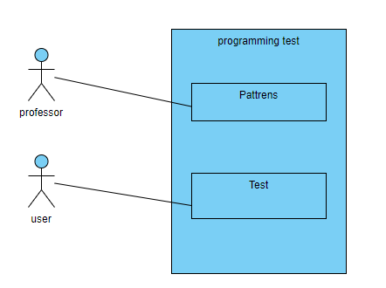

the test system has two active actors , user and prof , the prof is communication

with the system through the email , and the user accesses the entire system directly.

the division of the test system into two components parts

the patterns and the online test..

***2.2 Functional Requirements Specification***

This section outlines the use cases for each of the active actors separately. The user, the profs

Use case: **start the quiz  
Diagram:**

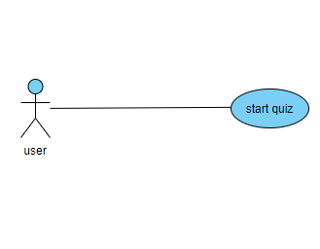

**Brief Description**

the user accesses the online test , choose the fields then start

then take the evaluation.

**Initial Step-By-Step Description**

.the user chooses the fields.1

2.the user chooses the level.

.the user start the quiz.3

.the user takes the evaluation.4

the user ask for the certificate..5

Use case: **takes pattrens  
Diagram:**

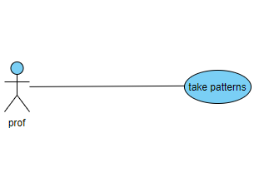

**Initial Step-By-Step Description**

1.send the BS certificate .

2.check it.

3.enter the kind of the question

4.recieve the pattrens.

Use case: **ask for certificate  
Diagram:**

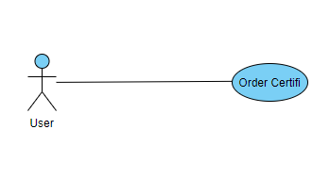

**Initial Step-By-Step Description**

check in db if the user had successed the exam..1

***2.3 User Characteristics***

the profi expected to be in external to be able to ask for the pattrens and get them by the email.

the user is expected to be internal with the system and can start the quiz.

***2.4 Non-Functional Requirements***

the speed performance of server,security of the quiz ,reliability

the quality of question

**3.0. Requirements Specification  
*3.1 External Interface Requirements***

None.

***3.2 Functional Requirements***

3.2.1 Start the quiz

|  |  |
| --- | --- |
| **Use Case Name** | start the quiz |
| **Trigger** | the user access the system and start the quiz. |
| **Precondition** | the login is required,  and sign up if it is the first time you accesss the system. |
| **Basic Path** | 1. the user sign in or log in and access to the system ,  and choose the kind of field and then choose the level of the question.. 2. if user choose 'advanced' , he should be pass the basic level  quiz , and enter the id of the certificate that he taked it . 3. the system determiante a time for the quiz , and start  showing the questions. 4. the user start the quiz , and finish when time is runing out. |
| **Alternative Paths** | if the user do not ask for the certificate  the system store the result of exam in database. that keyword or phrase and creates and presents a list of all such articles in the database. Return to step 5. |
| **Postcondition** | the system evaluate the choices , and if user want the certificate  the system ask for the personal detail(id , .. )  and after checking after a few dey the system send the certificate. |
| **Exception Paths** | The User may abandon the search at any time. |
|  |  |

3.2.2 Takes pattrens

|  |  |
| --- | --- |
| **Use Case Name** | Takes pattrens |
| **Trigger** | the prof communicate with the system and ask for  pattrens by email.. |
| **Precondition** | the prof should be send the BS certificate. |
| **Basic Path** | 1. the prof sign in or log in and access to the system 2. the prof select the pattren and the level and field 3. the system display the pattrens that he select 4. the prof download the pattrens. |
| **Alternative Paths** | None |
| **Postcondition** | the system will record the choosen pattrens and the prof info  in database. |
| **Exception Paths** | the prof may abandon the request. |
| **Other** | None |

3.2.3 Ask for certificate

|  |  |
| --- | --- |
| **Use Case Name** | Ask for certificate |
| **Trigger** | the user communicate with the system and ask for  certificate by internal request. |
| **Precondition** | he should be passed the quiz before that. |
| **Basic Path** | 1. the user should enter the personal info . 2. the system search for that in the database. 3. if he has passed quiz , the system prepare the certificate.   and saving it in the database , for next request time. |
| **Alternative Paths** | None |
| **Postcondition** | the user can download it. |
| **Exception Paths** | None |
| **Other** | None |

***3.3 Detailed Non-Functional Requirement***

***3.3.1 The speed performance of server:***

The speed of movement within the system, the smooth movement between questions, and the speed of the system's response to required commands

***security of the quiz 3.3.2***

Protecting the questions and answers by being unique and preventing any kind of cheating during the exam through conditions that the user must adhere to, otherwise he will be excluded from the exam if he violates one of them because by this action negatively affects the reliability of the system

***3.3.3 Reliability***

We have worked to document the questions and results, provided that they are accurate, in order to obtain high reliability, and the certificate is relied upon as a deliberate testimony and that its owner possesses all the information contained in the subject of the certificate

***3.3.4 The quality of question***.

We have made sure that the questions are of high scientific value and have been developed by specialists in the required field in a way that reduces the frequency of questions to a large extent to maintain the reliability of the exam